**Module: R3: DLD + DSD**

**Section:** Sequential Circuits **Task:** Assignment 2

**Assignment 2**

**Sequential Circuits**

* **Question 1: Design button press synchronizer:**

1. **FSM Diagram:**

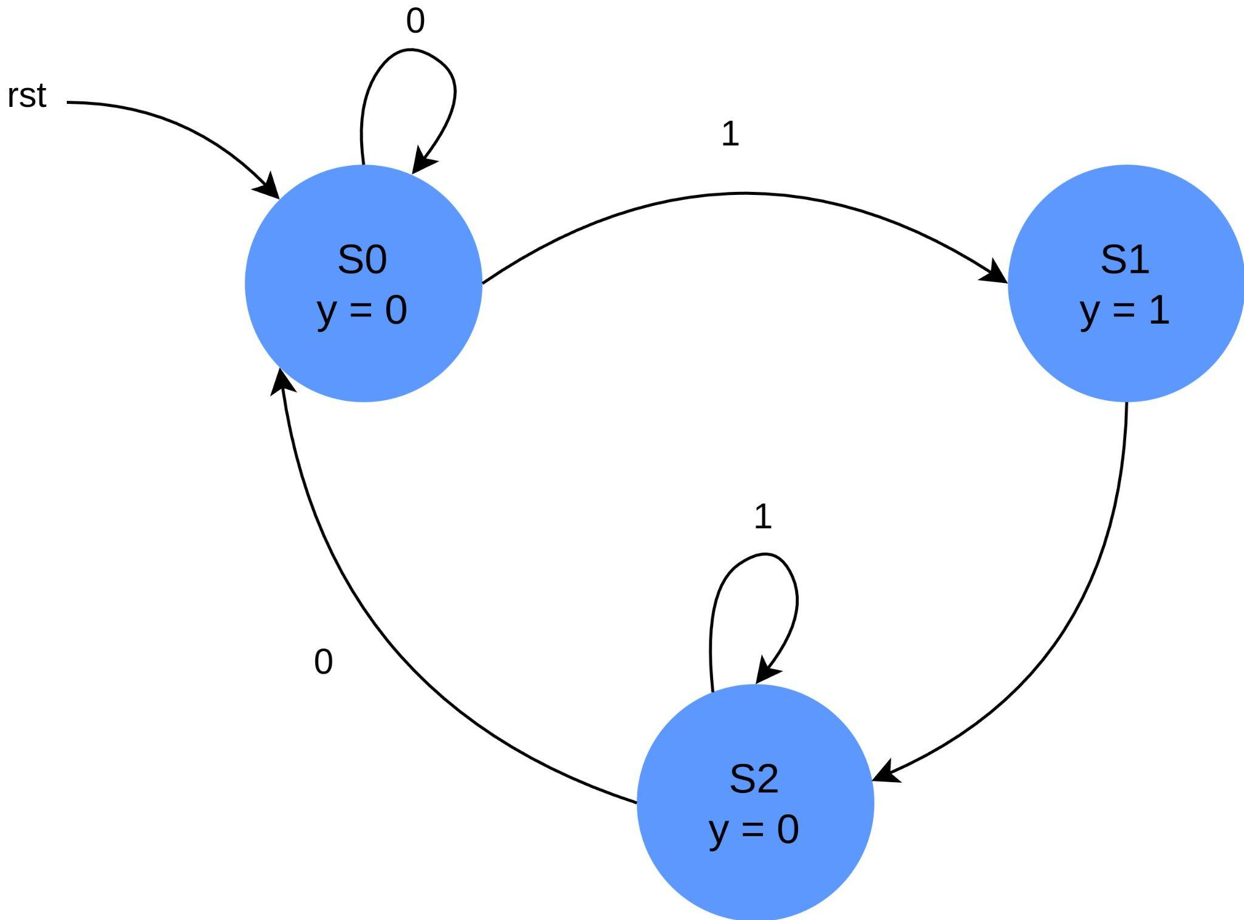

1. **Truth Table:**

| **One-Hot Encoding** | | **S0 = 001** | **S1 = 010** | **S2 = 100** |
| --- | --- | --- | --- | --- |

| Present State | | | Input | Next State | | | Output | Inputs to Flip-Flops | | |
| --- | --- | --- | --- | --- | --- | --- | --- | --- | --- | --- |
| QC | QB | QA | bi | QC+1 | QB+1 | QA+1 | bo | DC | DB | DA |
| 0 | 0 | 1 | 0 | 0 | 0 | 1 | 0 | 0 | 0 | 1 |
| 0 | 0 | 1 | 1 | 0 | 1 | 0 | 0 | 0 | 1 | 0 |
| 0 | 1 | 0 | 0 | 1 | 0 | 0 | 1 | 1 | 0 | 0 |
| 0 | 1 | 0 | 1 | 1 | 0 | 0 | 1 | 1 | 0 | 0 |
| 1 | 0 | 0 | 0 | 0 | 0 | 1 | 0 | 0 | 0 | 1 |
| 1 | 0 | 0 | 1 | 1 | 0 | 0 | 0 | 1 | 0 | 0 |

1. **Circuit Diagram:**

Using K-Maps:

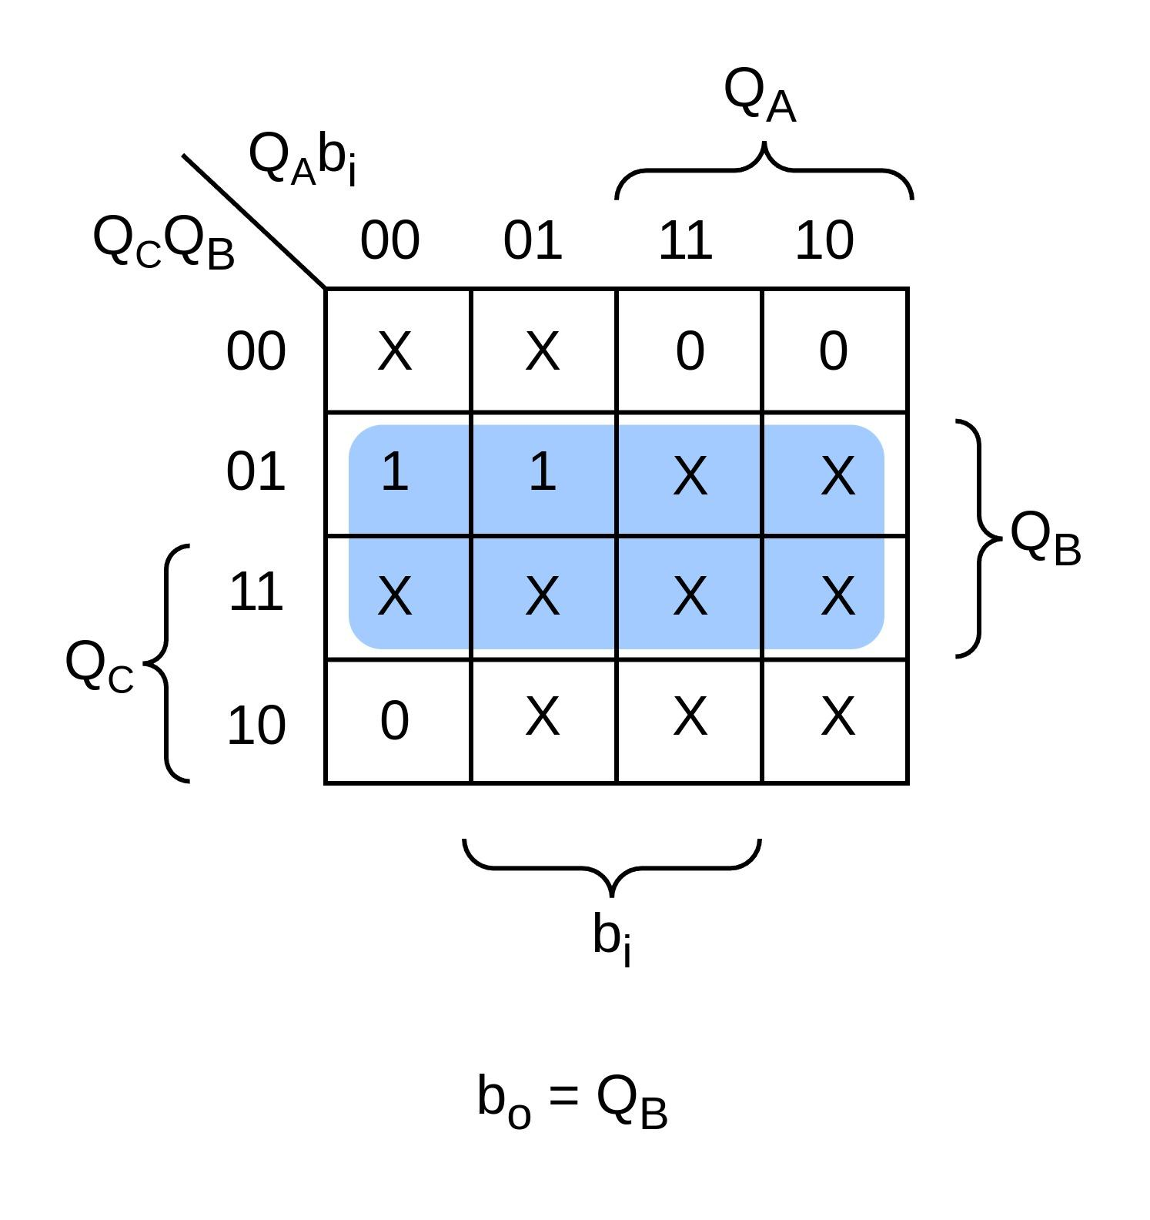 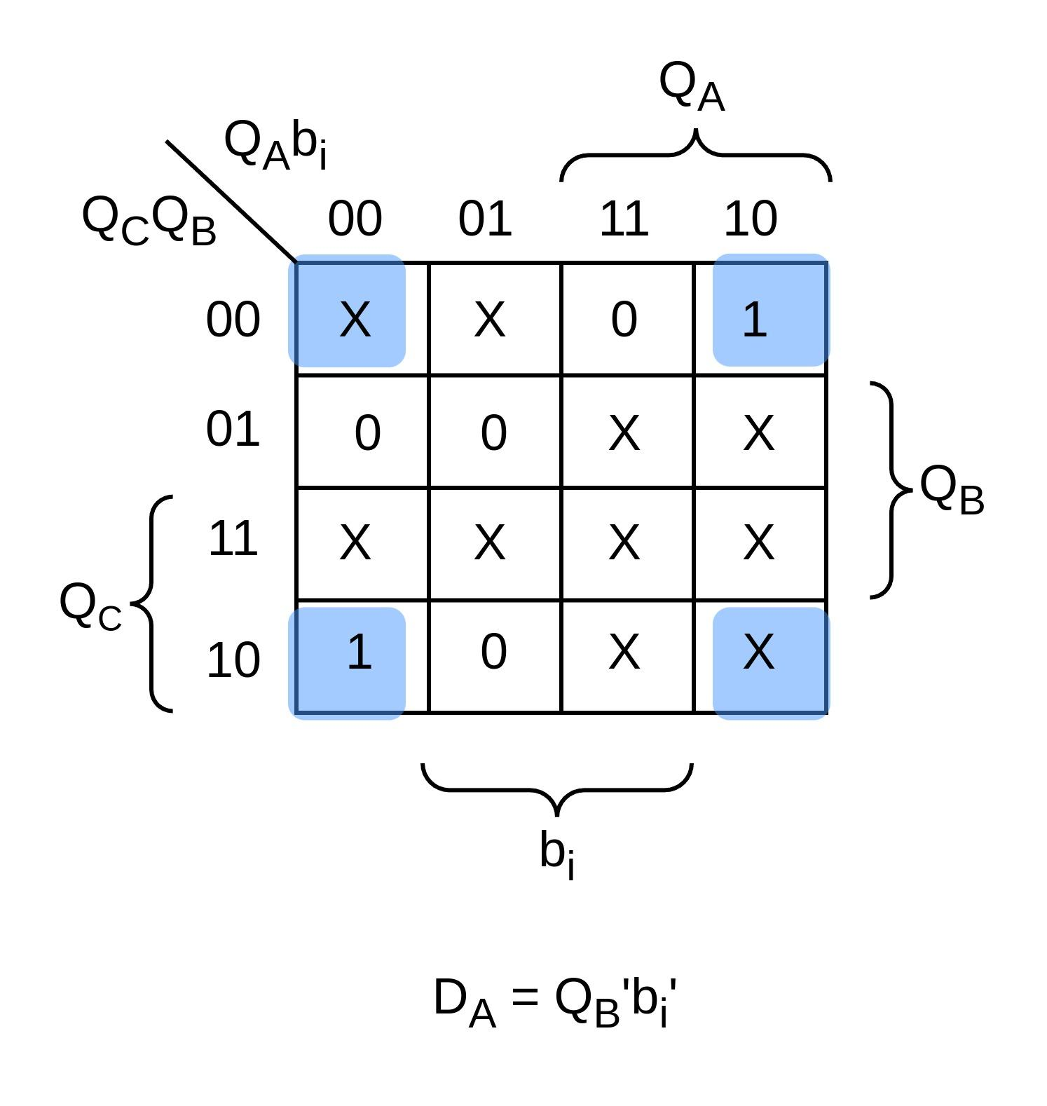

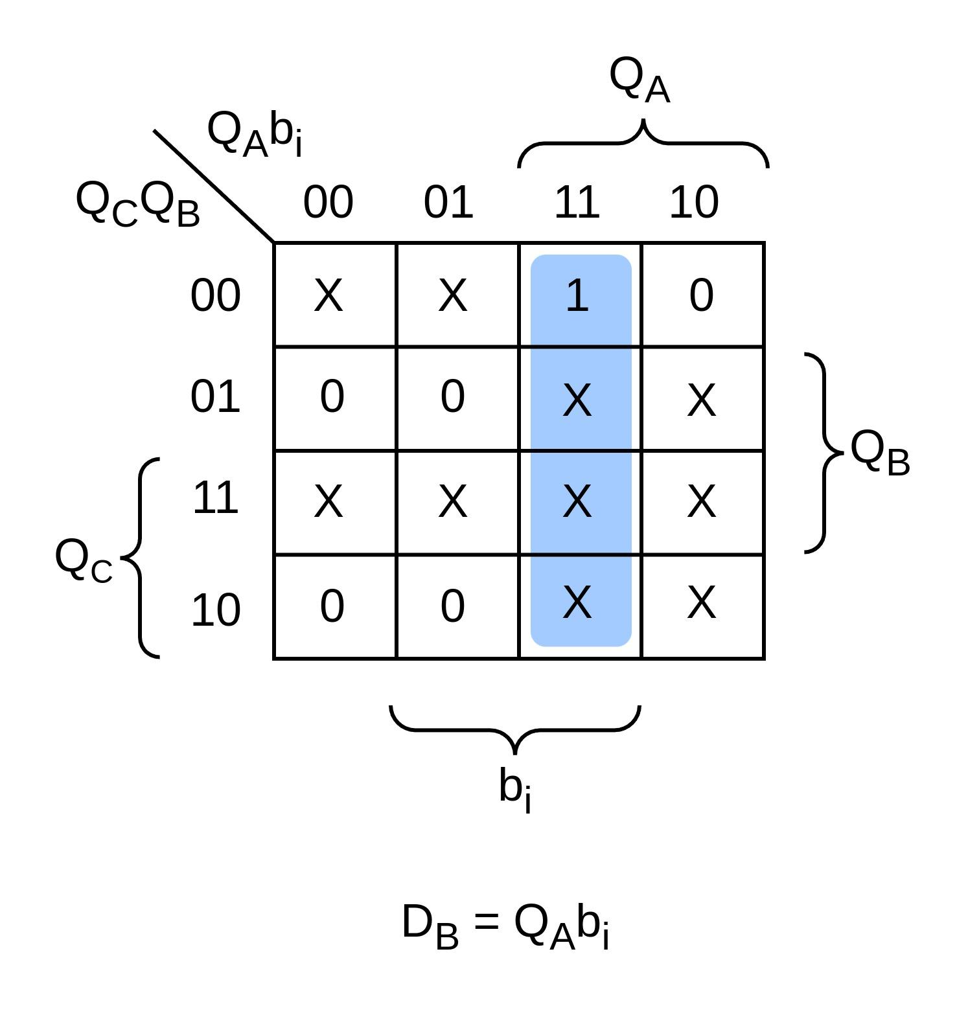 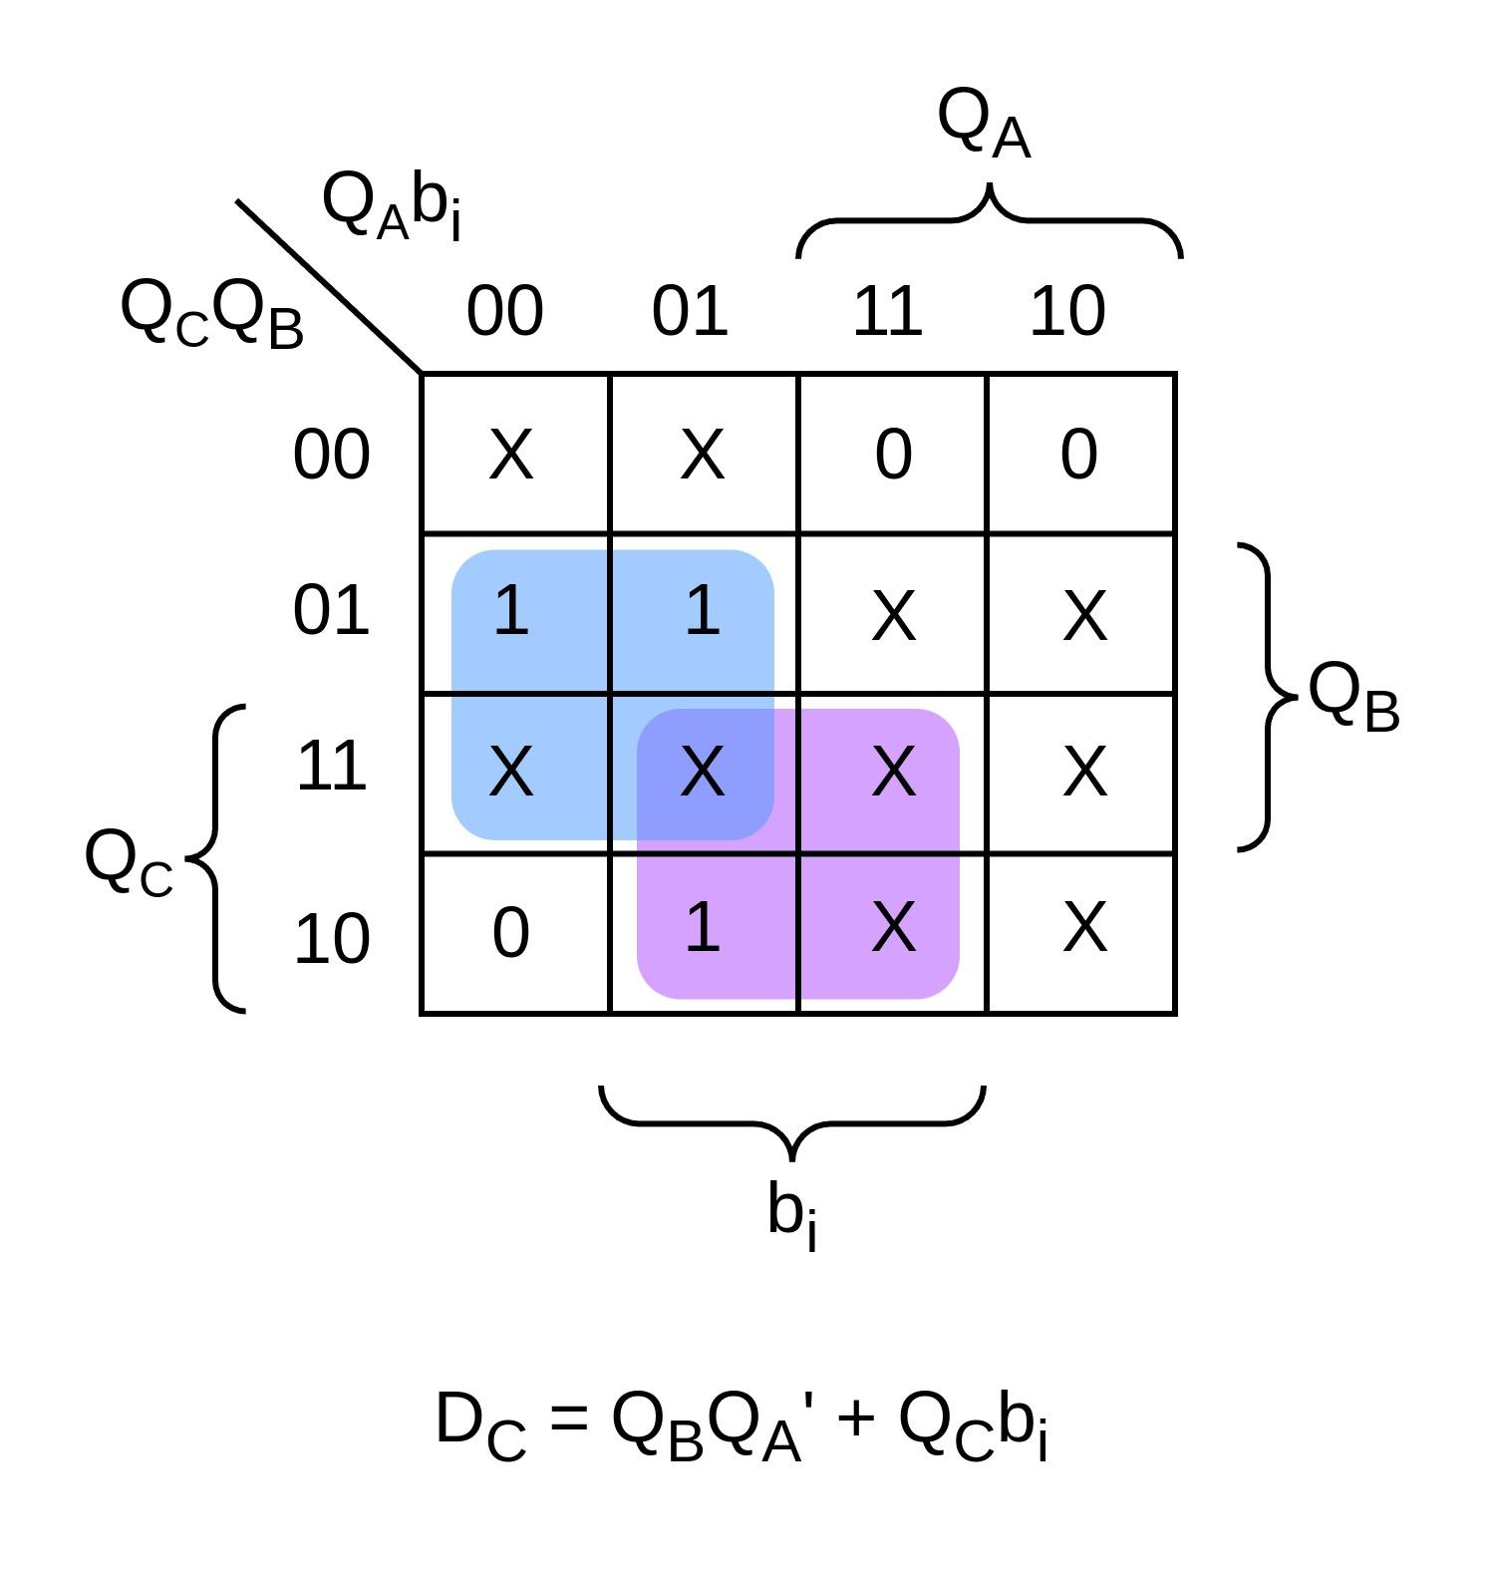

Here’s the final circuit:

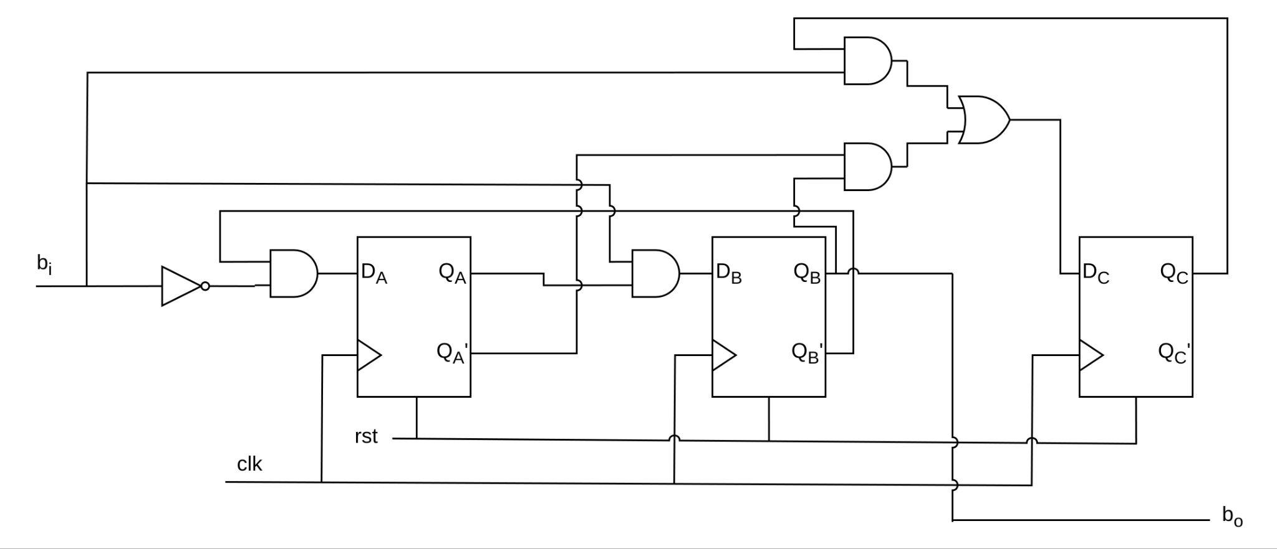

1. **Verilog Code:**

module button_press_synchronizer (input clk, rst, bi, output reg bo);

localparam S0 = 3'b001;

localparam S1 = 3'b010;

localparam S2 = 3'b100;

reg [2:0] state;

always @(posedge clk or posedge rst)

begin

if (rst)

state <= S0;

else

begin

case (state)

S0 : state <= bi? S1 : S0;

S1 : state <= S2;

S2 : state <= bi ? S2 : S0;

endcase

end

end

always @(state)

case (state)

S0 : bo <= 0;

S1 : bo <= 1;

S2 : bo <= 0;

default : bo <= bo;

endcase

endmodule

1. **Testbench:**

module tb_button_press_synchronizer;

reg clk, rst, bi;

wire bo;

button_press_synchronizer m1 (.clk(clk), .rst(rst), .bi(bi), .bo(bo));

always #5 clk = ~clk;

initial begin

$dumpvars;

clk = 0;

rst = 0;

bi = 0;

#10;

rst = 1;

bi = 1;

#20

rst = 0;

#30;

bi = 0;

#20;

bi = 1;

#50;

bi = 0;

#10;

bi = 1;

#20;

bi = 0;

$finish;

end

endmodule

1. **Output:**

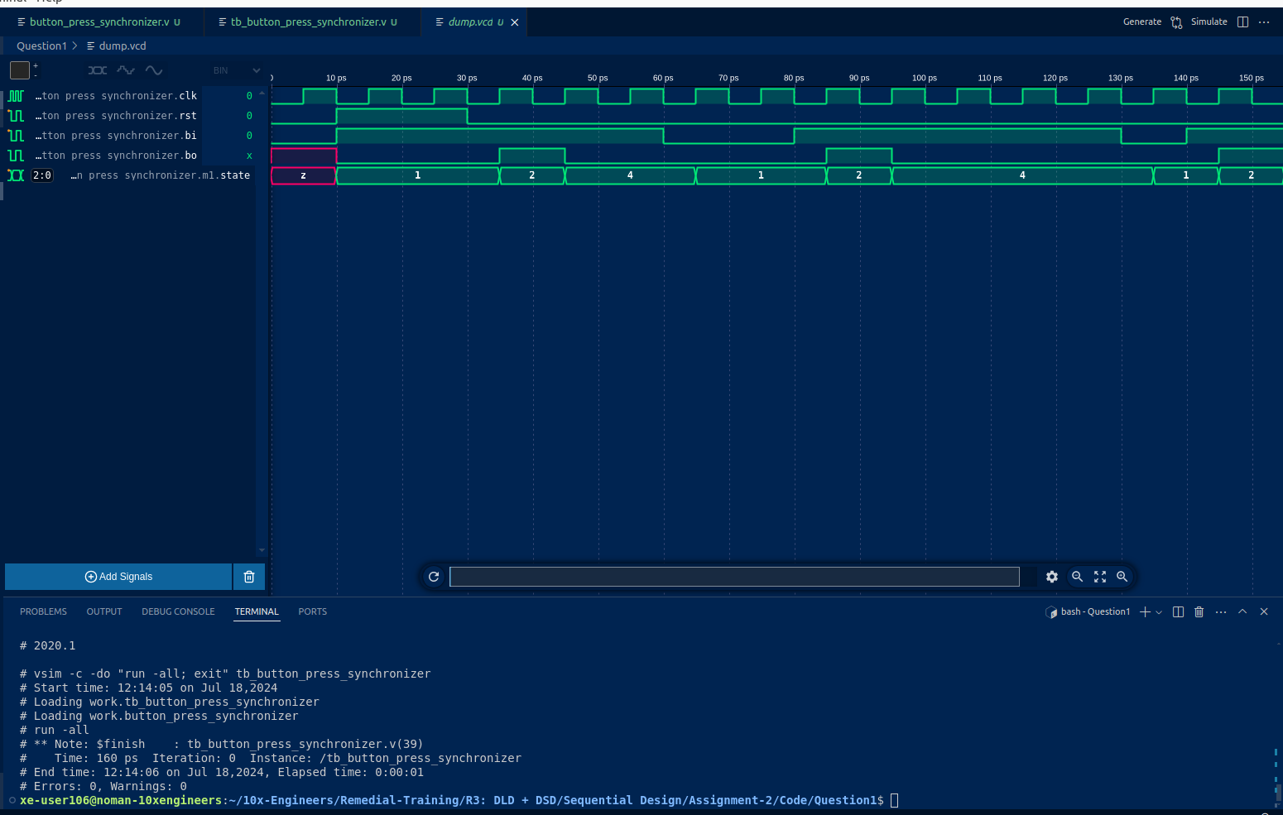

* **Question 2: Serial Input 2’s Complementer:**

1. **State Diagram:**

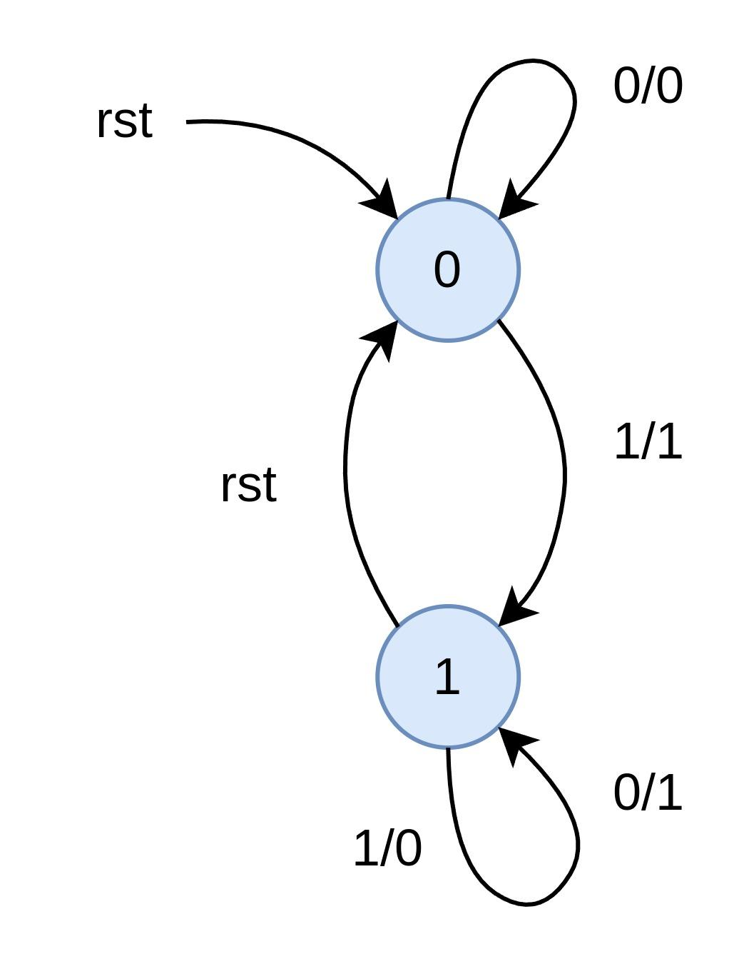

1. **State Table:**

| Present State | Input | Next State | Output | Flip-Flop Input |
| --- | --- | --- | --- | --- |
| Qt | x | Q(t+1) | y | D |
| 0 | 0 | 0 | 0 | 0 |
| 0 | 1 | 1 | 1 | 1 |
| 1 | 0 | 1 | 1 | 1 |
| 1 | 1 | 1 | 0 | 1 |

K-maps:

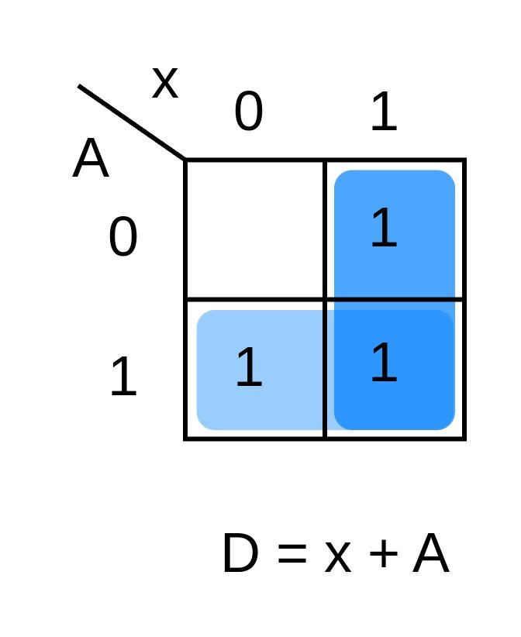 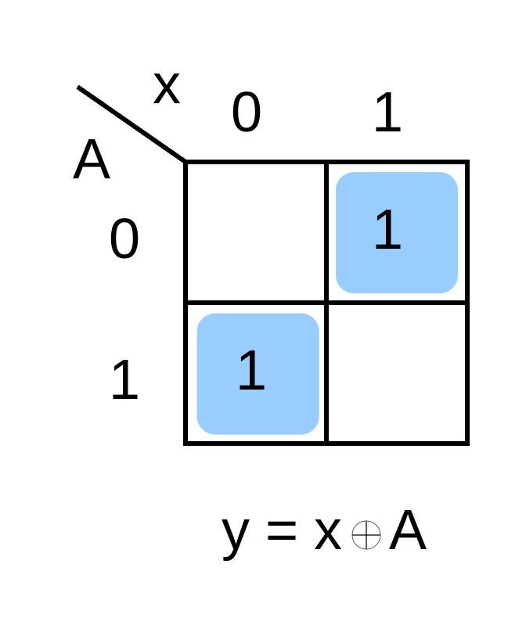

1. **Circuit Diagram:**

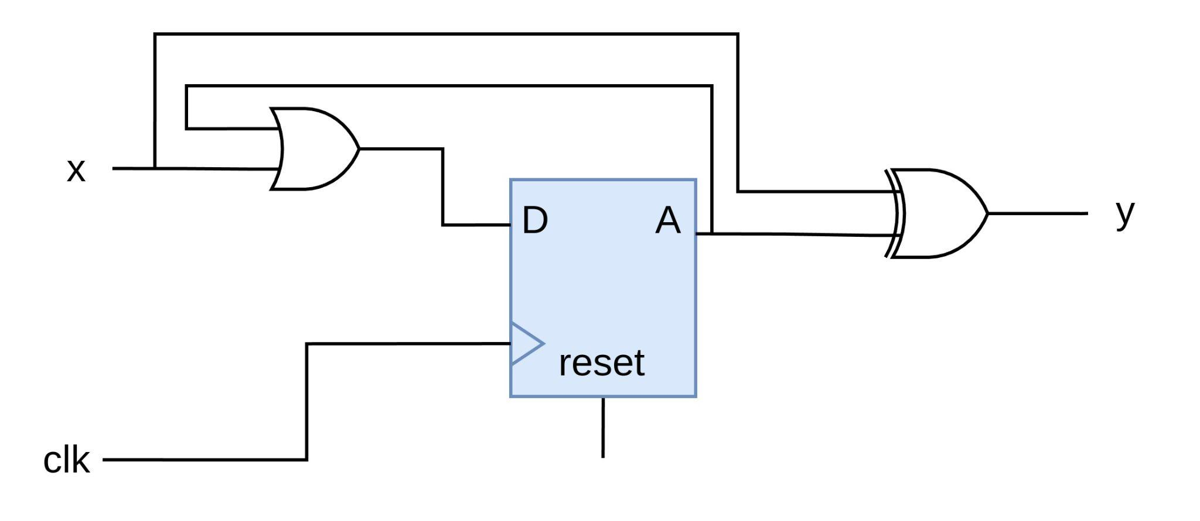

* **Question 3: Timing Diagram:**

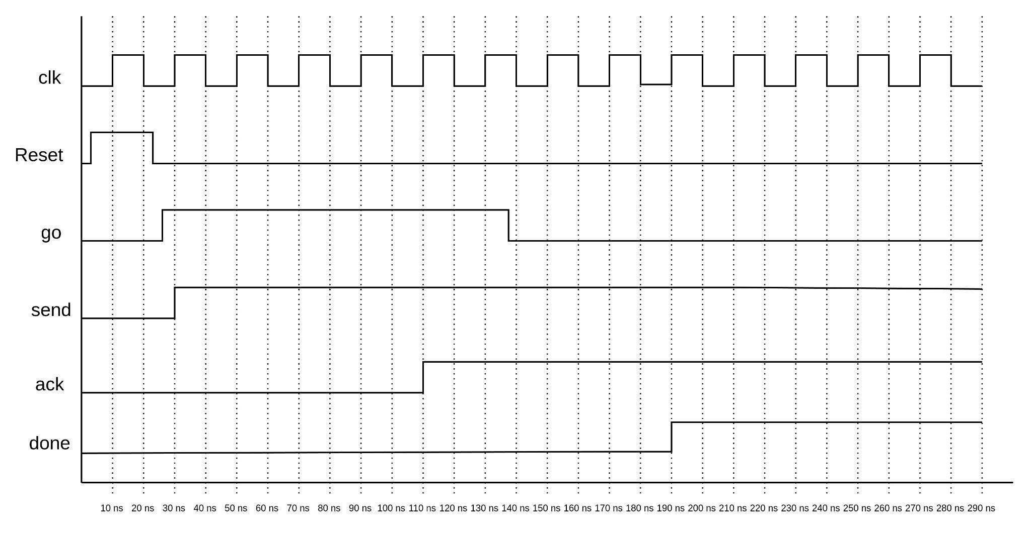

* **Question 4: Pulse Detector:**
  1. **FSM Diagram:**

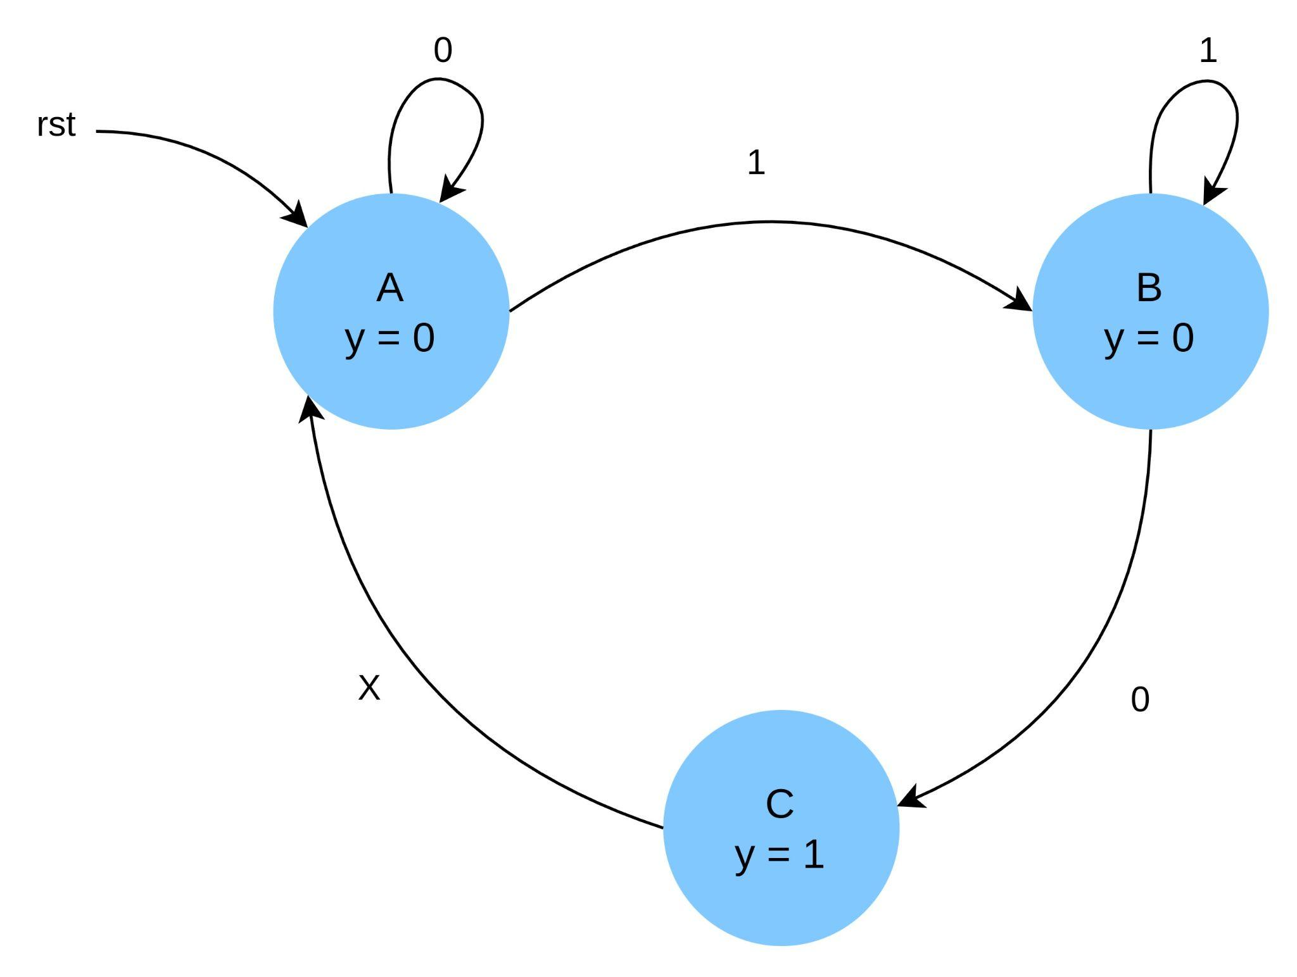

* 1. **Truth Table:**

| **One-Hot Encoding** | | **A = 001** | **B = 010** | **C = 100** |
| --- | --- | --- | --- | --- |

| Present State | | | Input | Next State | | | Output | Inputs to Flip-Flops | | |
| --- | --- | --- | --- | --- | --- | --- | --- | --- | --- | --- |
| QC | QB | QA | x | QC+1 | QB+1 | QA+1 | y | DC | DB | DA |
| 0 | 0 | 1 | 0 | 0 | 0 | 1 | 0 | 0 | 0 | 1 |
| 0 | 0 | 1 | 1 | 0 | 1 | 0 | 0 | 0 | 1 | 0 |
| 0 | 1 | 0 | 0 | 1 | 0 | 0 | 1 | 1 | 0 | 0 |
| 0 | 1 | 0 | 1 | 0 | 1 | 0 | 1 | 0 | 1 | 0 |
| 1 | 0 | 0 | 0 | 0 | 0 | 1 | 0 | 0 | 0 | 1 |
| 1 | 0 | 0 | 1 | 0 | 0 | 1 | 0 | 0 | 0 | 1 |

1. **Circuit Diagram:**

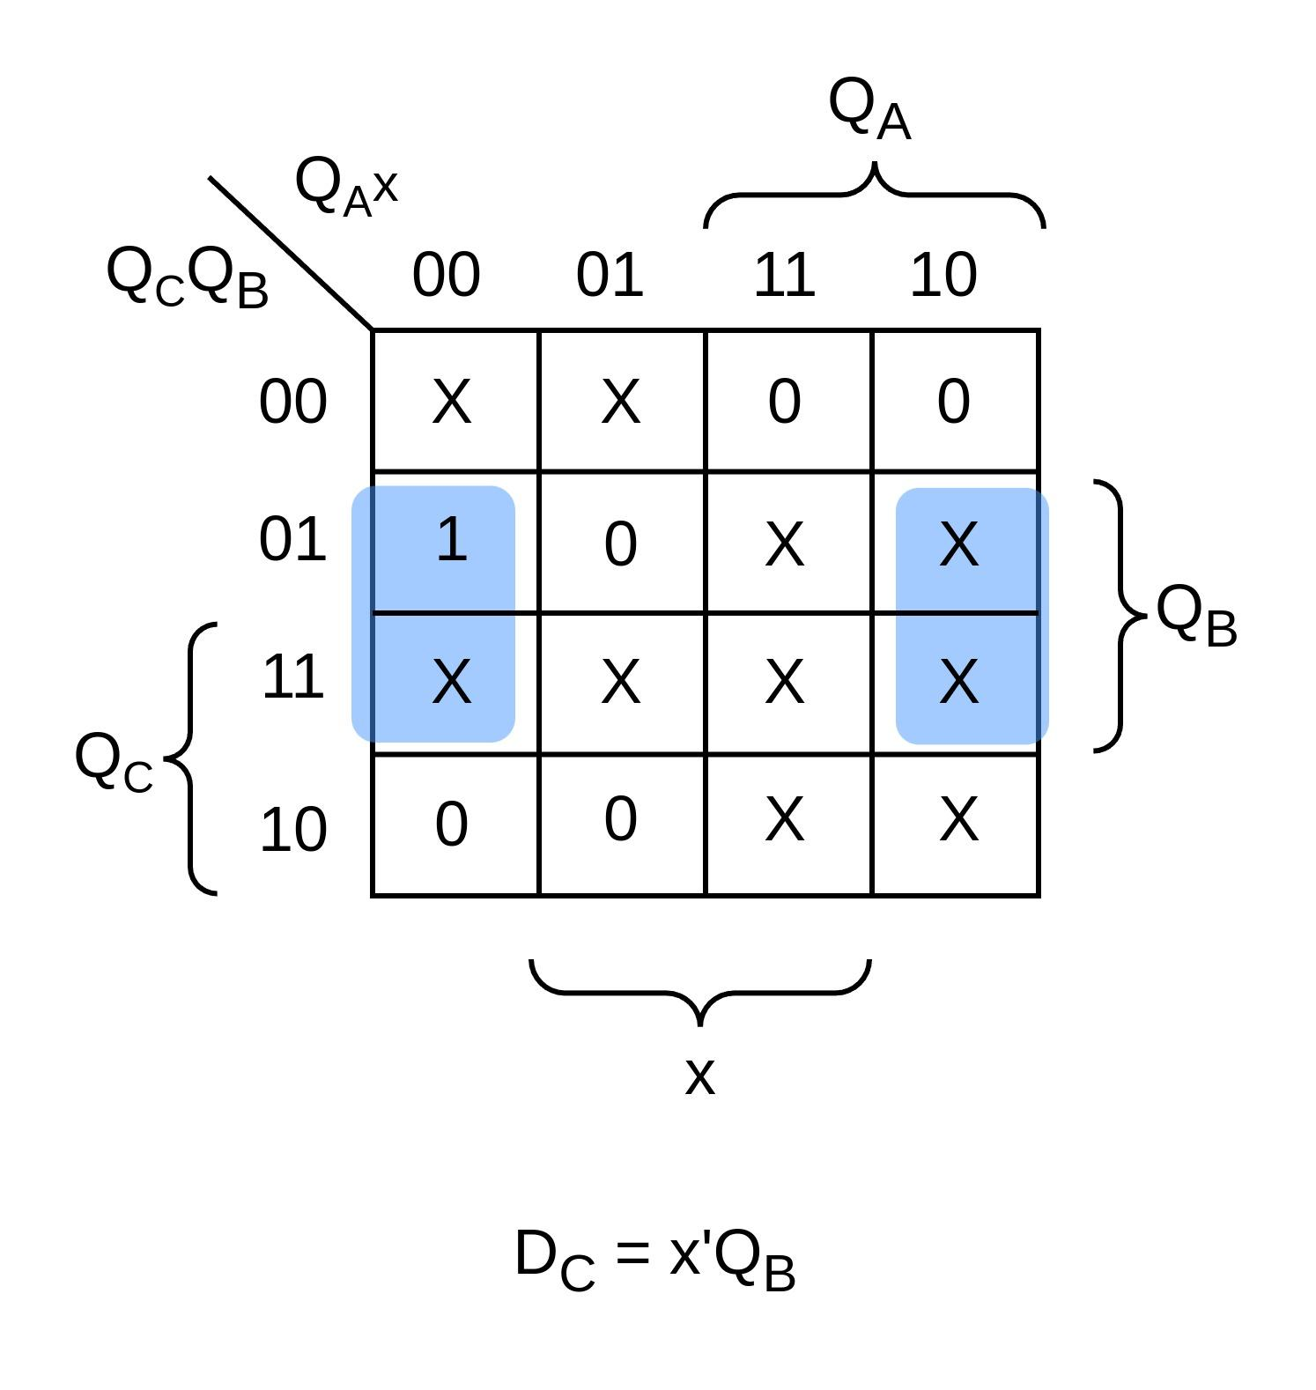 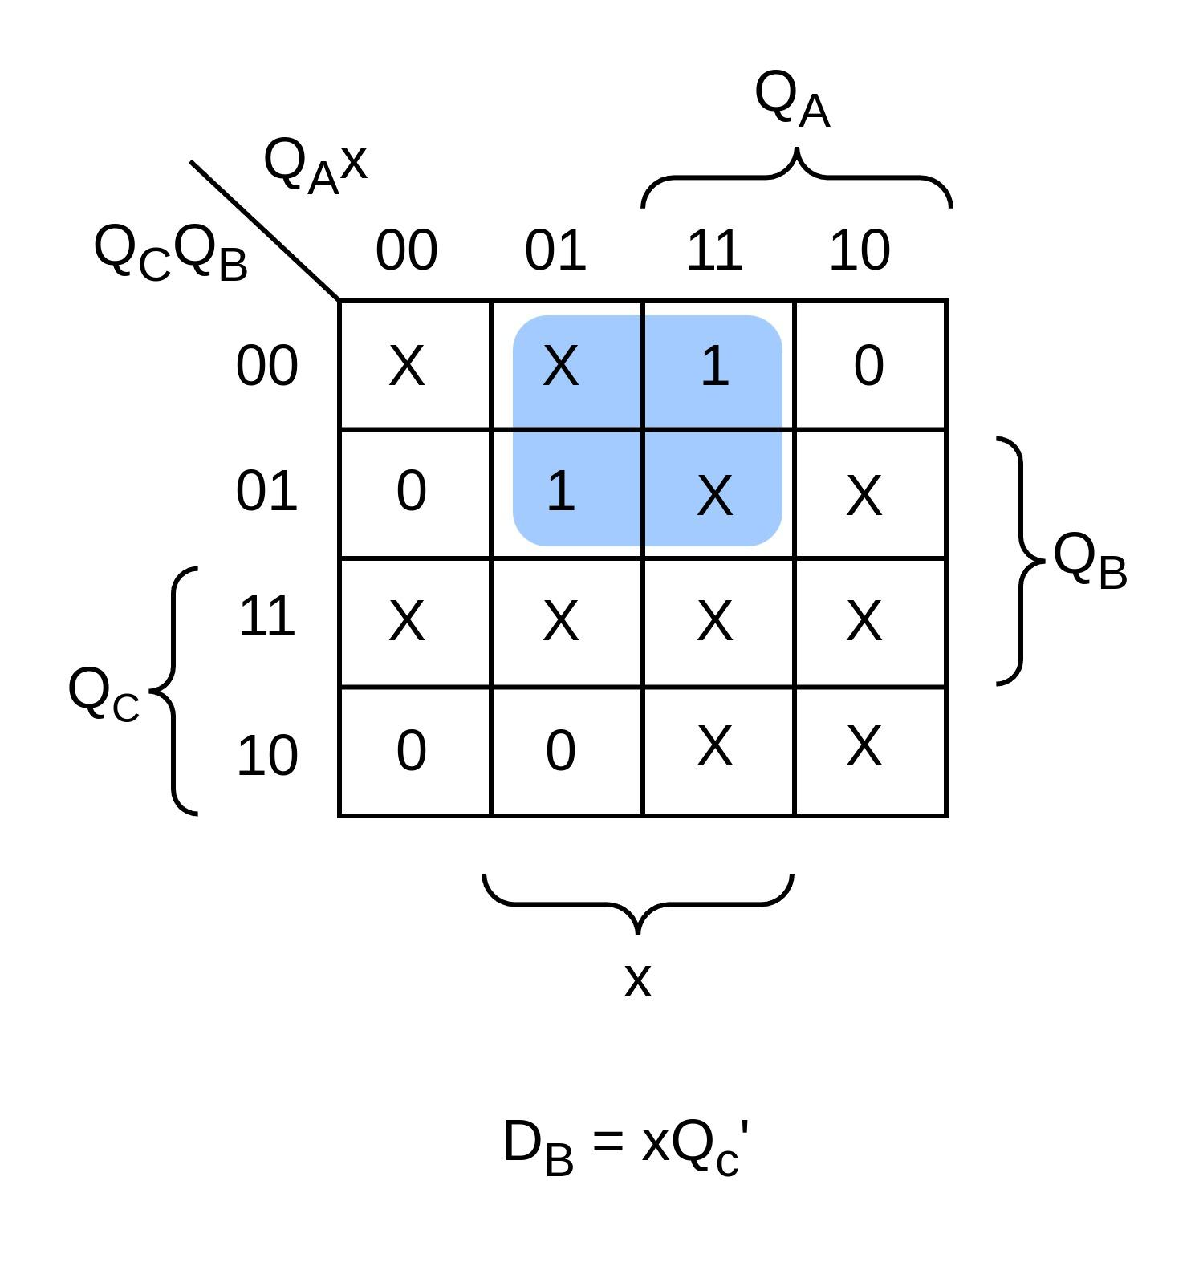

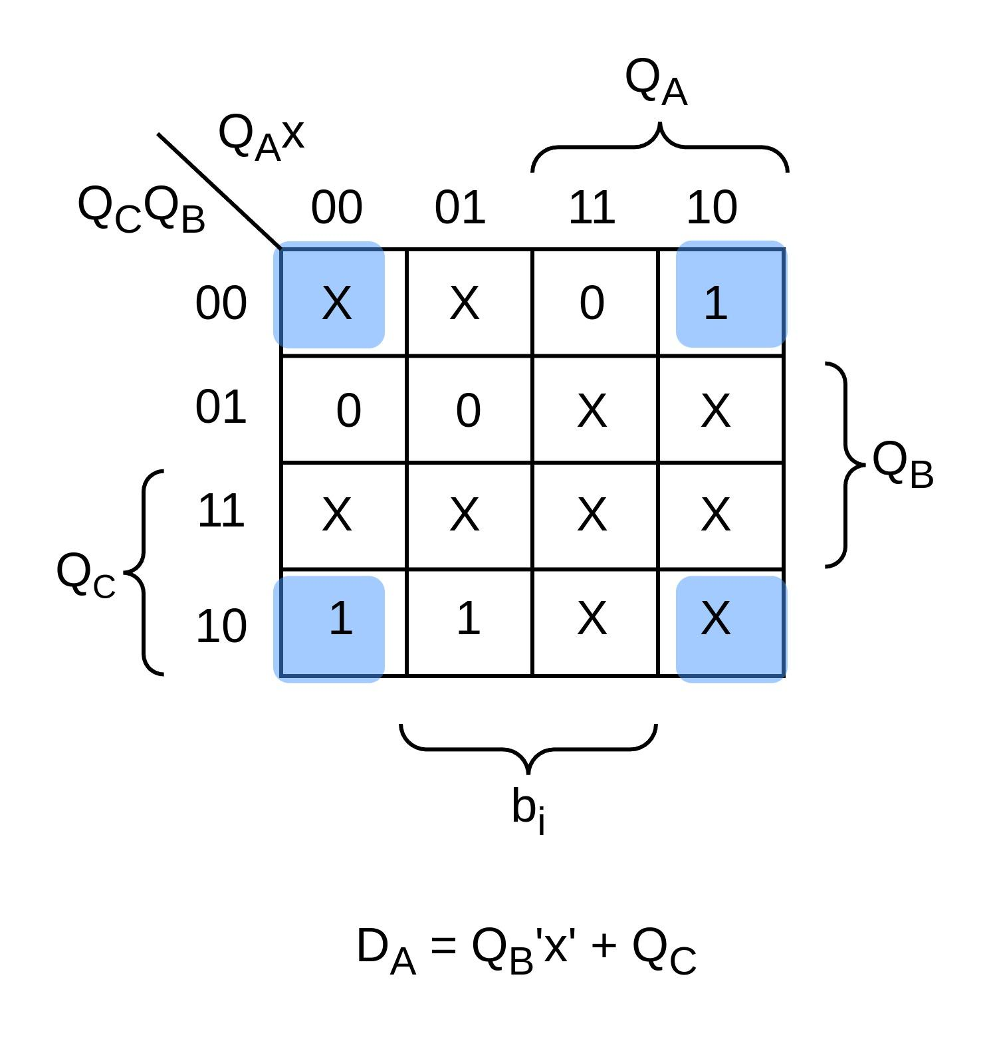 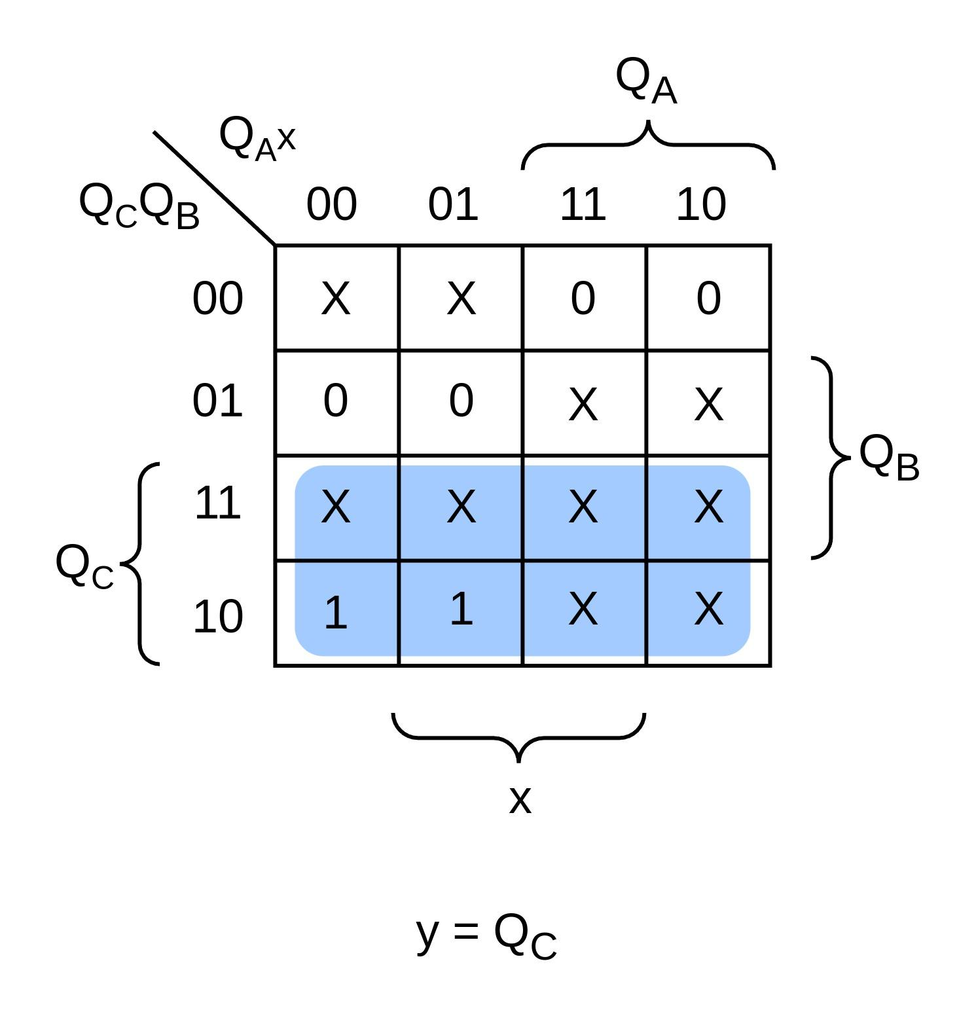

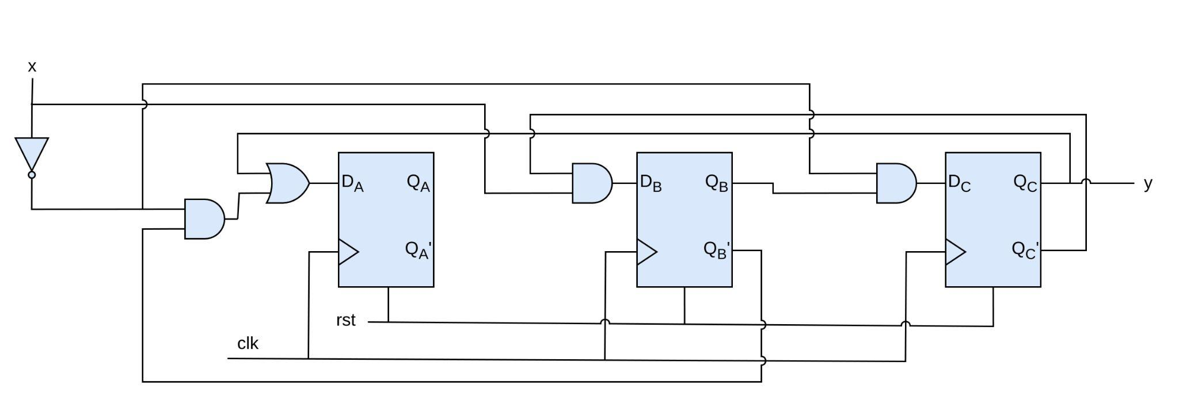

1. **Verilog Code:**

module pulse_detector (input clk, rst, x, output reg y);

localparam A = 3'b001;

localparam B = 3'b010;

localparam C = 3'b100;

reg [2:0] state, next_state;

reg x_previous;

//State-Transition

always @(posedge clk or rst)

begin

if (rst)

state <= A;

else

state <= next_state;

end

//Next-State Logic

always @(*)

begin

case (state)

A :

begin

if (!x)

next_state <= A;

else

next_state <= B;

end

B :

begin

if (!x && x_previous)

next_state <= C;

else

next_state <= B;

end

C : next_state <= A;

default : next_state <= A;

endcase

end

//Output

always @(posedge clk or posedge rst)

begin

if (rst)

y <= 0;

else if (state == C)

y <= 1;

else

y <= 0;

end

//Detect Falling-Edge

always @(posedge clk or posedge rst)

begin

if (rst)

x_previous <= 1;

else

x_previous <= x;

end

endmodule

1. **Testbench:**

module tb_pulse_detector;

reg clk, rst, x;

wire y;

pulse_detector m0 (.clk(clk), .rst(rst), .x(x), .y(y));

always #5 clk = ~clk;

initial begin

$dumpvars;

clk = 0;

rst = 0;

x = 1;

#20;

rst = 1;

#20;

rst = 0;

#10;

x = 0;

#20;

x = 1;

#20;

x = 0;

#30;

x = 1;

#40;

rst = 1;

#10;

x = 0;

#30;

x = 1;

rst = 0;

#40;

$finish;

end

endmodule

1. **Output:**

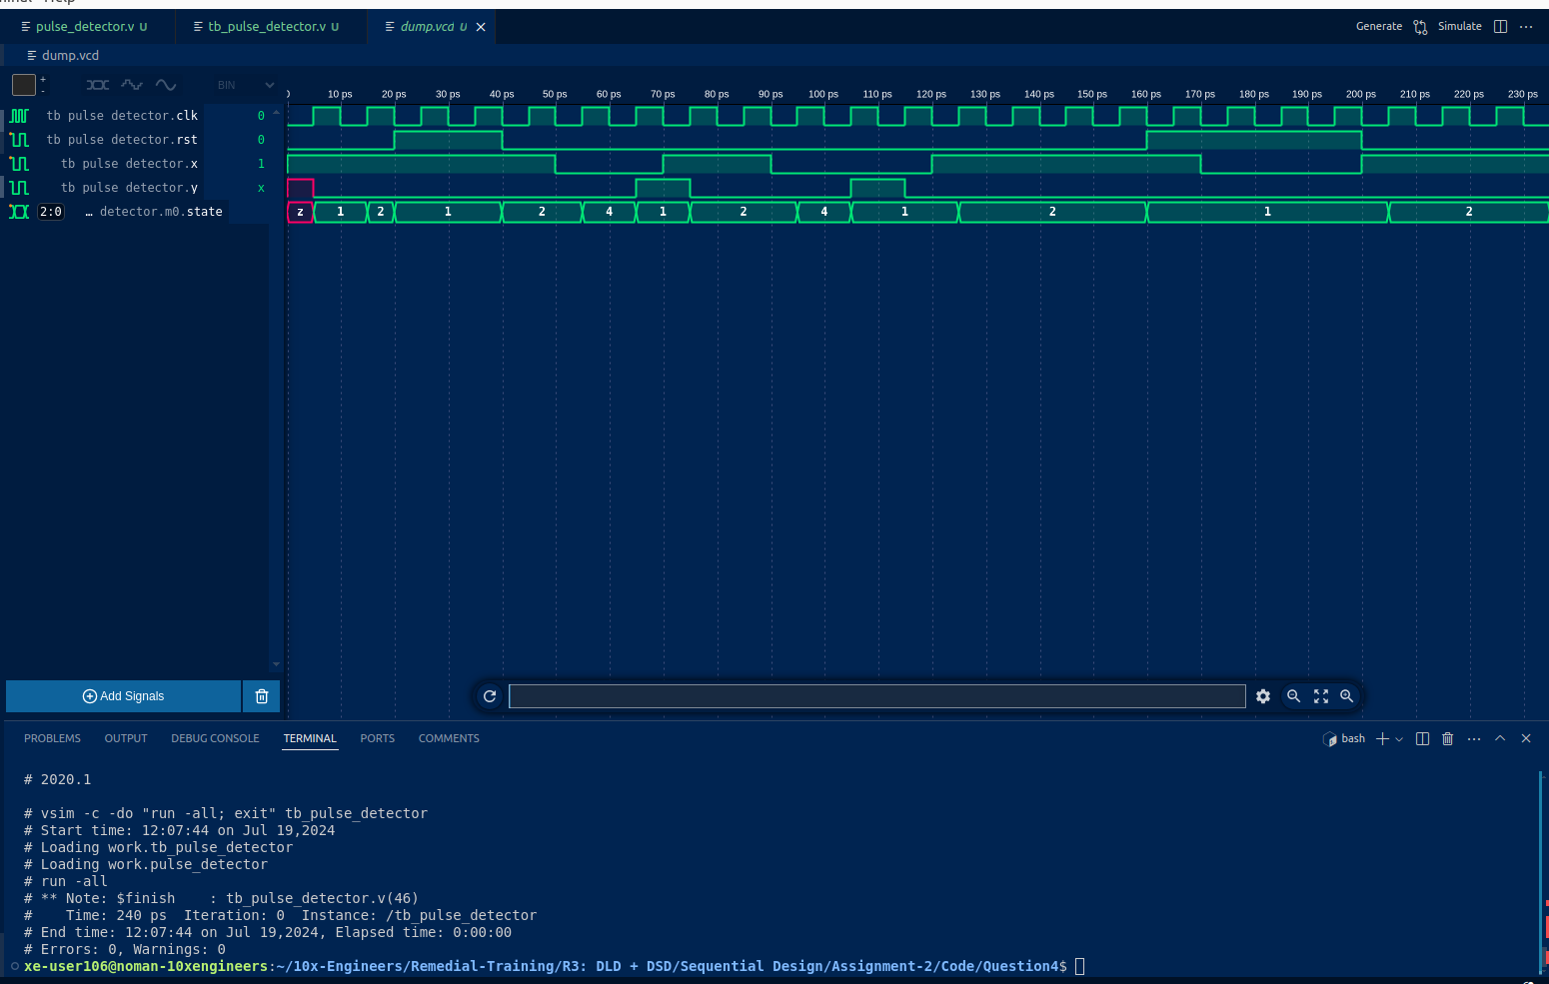

* **Question 5: Asynhcronus reset:**

Since we are dealing with 2 different clock domains. Hence, in order to avoid any glitches or metastability, I’ll be using a two-flop synchronizer ciruit to map the **reset_A** signal synchronously with clock of domain B (**clk_B**)

* 1. **Circuit Diagram:**

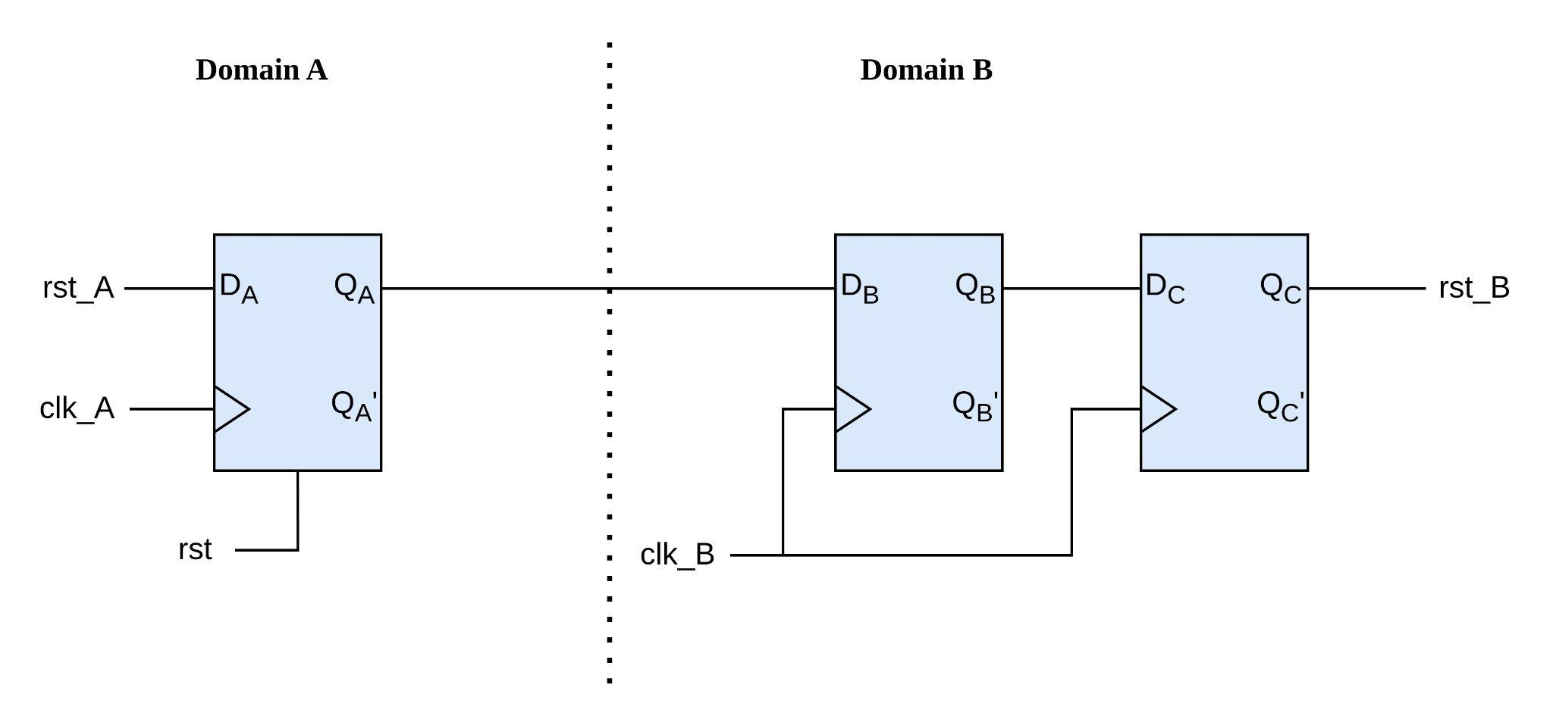

* 1. **Verilog Code:**

module d_ff (input clk, rst, d, output reg q);

always @(posedge clk or posedge rst) begin

if (rst)

q <= 1'b0;

else

q <= d;

end

endmodule

module synchronizer (input clk_A, clk_B, rst_A, rst, output reg rst_B);

wire w0, w1, w2;

d_ff m0 (.clk(clk_A), .rst(rst), .d(rst_A), .q(w0));

//Two Flops Synchronizer

d_ff m1 (.clk(clk_B), .rst(1'b0), .d(w0), .q(w1));

d_ff m2 (.clk(clk_B), .rst(1'b0), .d(w1), .q(w2));

assign rst_B = w2;

endmodule

* 1. **Testbench:**

module tb_synchronizer;

reg clk_A, clk_B, rst, rst_A;

wire rst_B;

synchronizer dut (.clk_A(clk_A), .clk_B(clk_B), .rst(rst), .rst_A(rst_A), .rst_B(rst_B));

always #5 clk_A = ~clk_A;

always #20 clk_B = ~clk_B;

initial begin

$dumpvars;

clk_A = 0;

clk_B = 0;

rst = 0;

rst_A = 0;

#20;

rst = 1;

#10;

rst_A = 1;

#40;

rst = 0;

#40;

rst_A = 0;

#80;

rst_A = 1;

#20;

rst_A = 0;

#30;

rst_A = 1;

#30;

rst_A = 0;

#100;

$finish;

end

endmodule

* 1. **Output:**

